Project Design Phase-II Technology Stack (Architecture & Stack)

|  |  |
| --- | --- |
| Date | 03 October 2022 |
| Team ID | PNT2022TMID44897 |
| Project Name | AI-based localization and classification of  skin disease with erythema |
| Maximum Marks | 4 Marks |

# Technical Architecture:

The Deliverable shall include the architectural diagram as below and the information as per the table1 & table 2

**Example:** AI-based localization and classification of skin disease with erythema

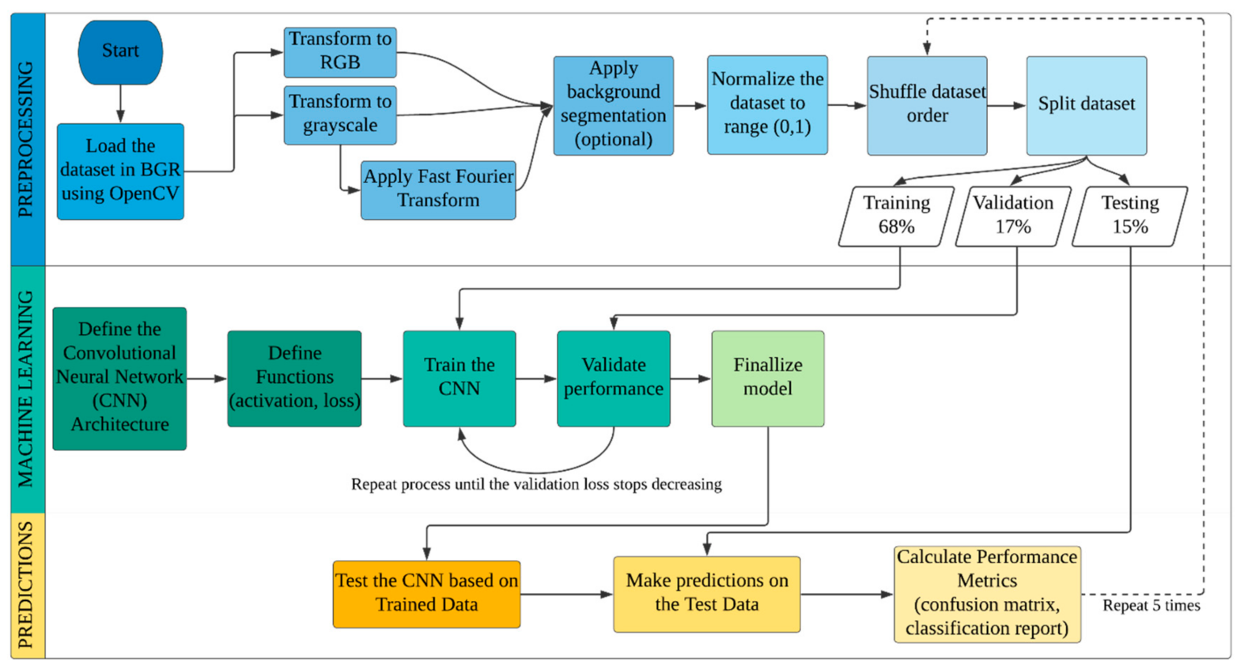

# Table-1 : Components & Technologies:

|  |  |  |  |
| --- | --- | --- | --- |
| **S.No** | **Component** | **Description** | **Technology** |
| 1. | User Interface | User interacts with the application using a website | Python |
| 2. | Image Pre-processing | Image of the diseased spot is uploaded through  the website and the image is pre-processed using machine learning algorithms. | Python |
| 3. | Disease Prediction | Machine learning model to predict the diseases from the images of the diseases uploaded through  the webapp | Python |
| 4. | Mitigation | After predicting the disease, identification and mitigation that particular disease is suggested. Watson Assistant plays a great role in assisting in  these processes. | Python, IBM Watson Assistant |
| 5. | Database | Images are stored in the database | MySQL, etc. |
| 6. | Cloud Database | The above-described model is deployed in the IBM cloud. | IBM DB2, IBM Cloudant etc. |
| 7. | File Storage | Files are been stored in cloud. | IBM Block Storage or Other Storage Service or Local Filesystem |
| 8. | External API-1 | API is used for the verification of aadhar to authenticate the user. | Aadhar API, etc. |
| 9. | Machine Learning Model | Machine learning models are used for image pre- processing, disease prediction and mitigation steps | Image pre-processing model, Disease Prediction model |
| 10. | Infrastructure (Server / Cloud) | Application Deployment on Cloud  Cloud Server Configuration : Default | IBM cloud |

**Table-2: Application Characteristics:**

|  |  |  |  |
| --- | --- | --- | --- |
| **S.No** | **Characteristics** | **Description** | **Technology** |
| 1. | Open-Source Frameworks | Google Collaboratory, Jupyter Notebook, Google drive, Python Flask. | Google coloboratory,python |
| 2. | Security Implementations | Some kind of encryption will be done, as this is a  web app the owasp will be taken into consideration. | SHA-256, Encryptions, IAM Controls, OWASP etc. |
| 3. | Scalable Architecture | The scalability architecture used is 2-tier architecture. The client is the user and the server is the IBM cloud server where the model will be deployed. | Python Flask, IBM cloud |
| 4. | Availability | The website will be deployed in the IBM cloud and  will be available for all the users to use irrespective of the organisation or the institution they belong to. | IBM cloud |
| 5. | Performance | As the models and the web applications are deployed in the IBM cloud remote server the  website can handle maximum number of requests and can be scaled at ease. | IBM cloud |